Building an Open Source IoT Garage Controller
Daniel A. Zajac  Department of Electrical and Computer Engineering  University of Michigan  danzajac@umich.edu | Jackson Harmer  Department of Electrical and Computer Engineering  University of Michigan  jharmer@umich.edu

Abstract— Internet connected technologies have become mainstays of the modern household. From Internet of Things (IoT) connected coffee makers to sophisticated adaptive climate control systems, inexpensive wireless technology and popularity of voice activated digital assistants has enabled a wide variety of connected tech. Most of this technology remains closed source however. Many of the more popular connected technologies, such as Nest or ecoBee, rely on closed source protocols and cloud service backends. What happens when these companies go out of business or shut down older services? VueZone shutdown it’s services leaving owners with severely crippled expensive IoT cameras. [1] This paper focuses on building a proof of concept IoT connected garage door real time controller and fully published interface and source: The GarageRTC! The features, design, and implementation of a reference architecture built on an ESP32 microcontroller and FreeRTOS software as well as performance and possible improvements.
Keywords—GarageRTC, IoT, Embedded, FreeRTOS, ESP32, NodeMCU, RTOS

Introduction

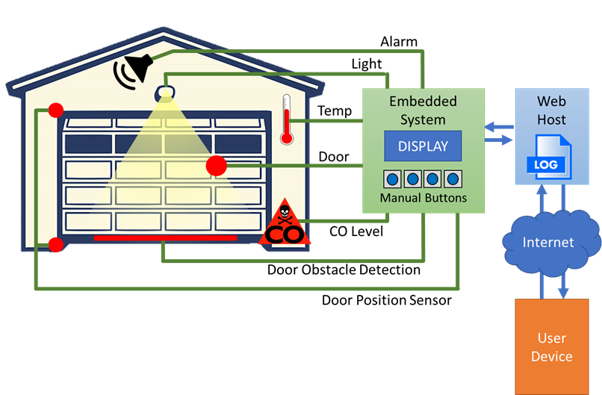

Organization of this Paper

Existing State of the Art

Design Process
This project was developed using a waterfall

Objective and Functional Description

Requirements

High Level Design

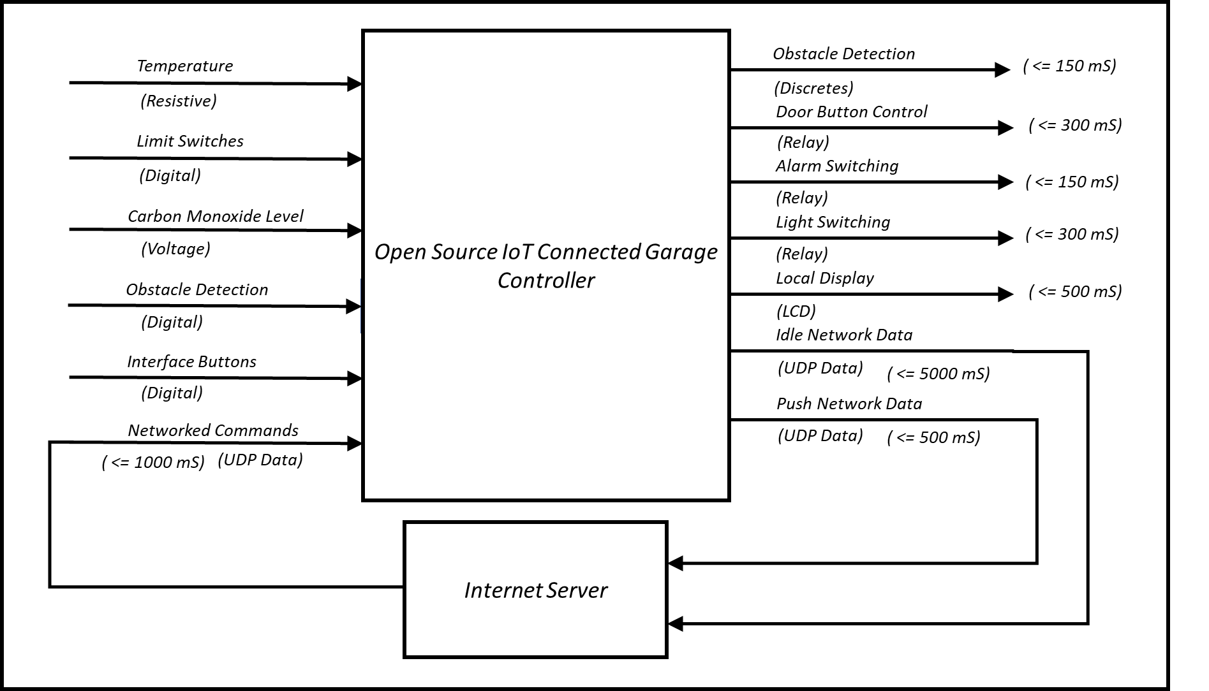

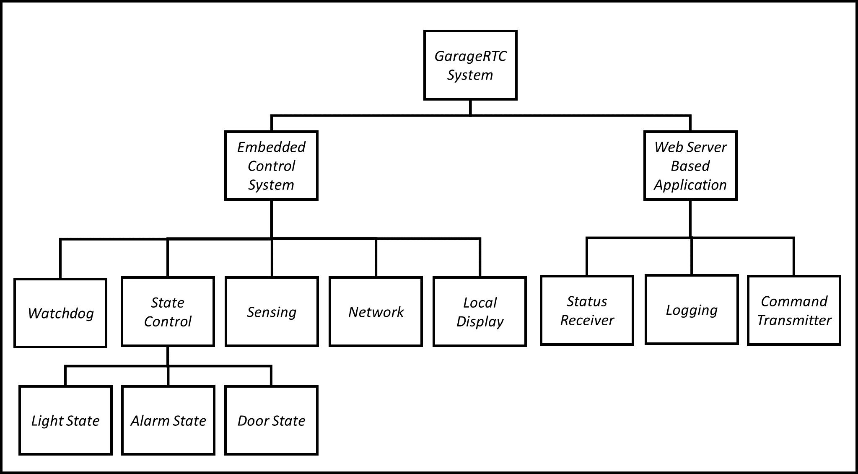

Embedded System
For the embedded system, a real-time OS was necessary to provide predictable response to inputs while simultaneously executing multiple tasks in a timely fashion. While scratch development of a RTOS was considered, ultimately the FreeRTOS project was selected. FreeRTOS implements a real-time kernel and schedulers targeted as low resource microcontrollers. The project is professionally developed and is available for free use in commercial embedded systems. It supports a wide variety of hardware and offers excellent documentation and, most importantly, is freely available including source. [2]

Web Application

Detail Design

Implementation

Embedded System

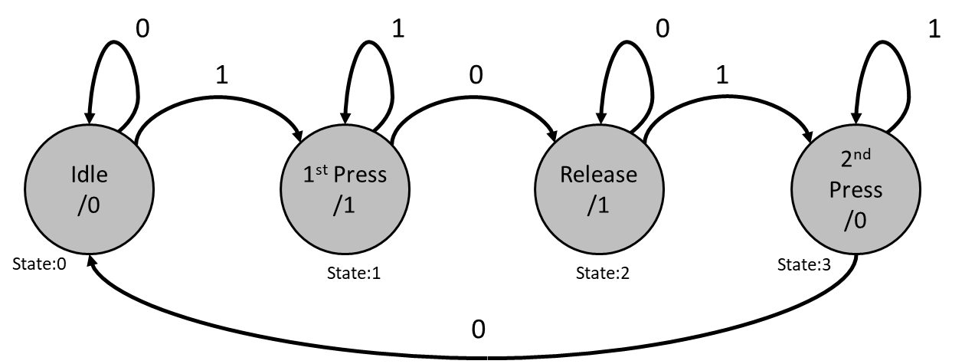

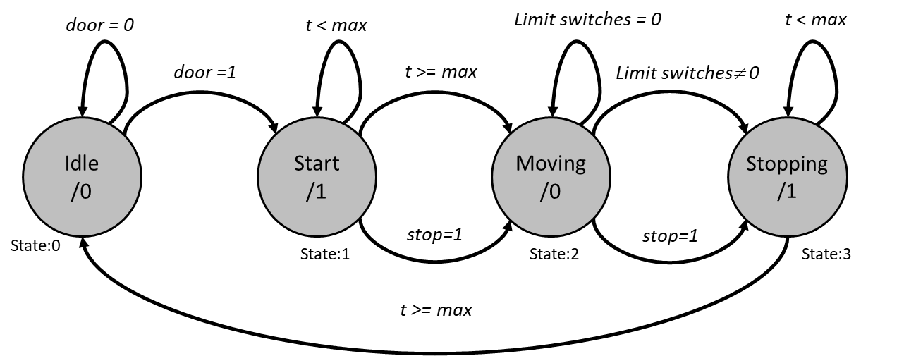

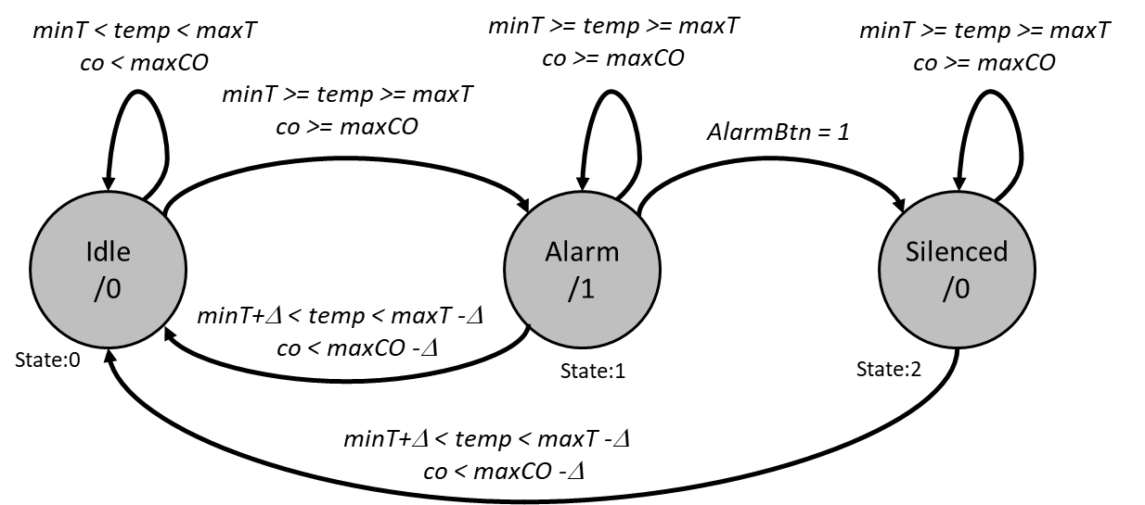

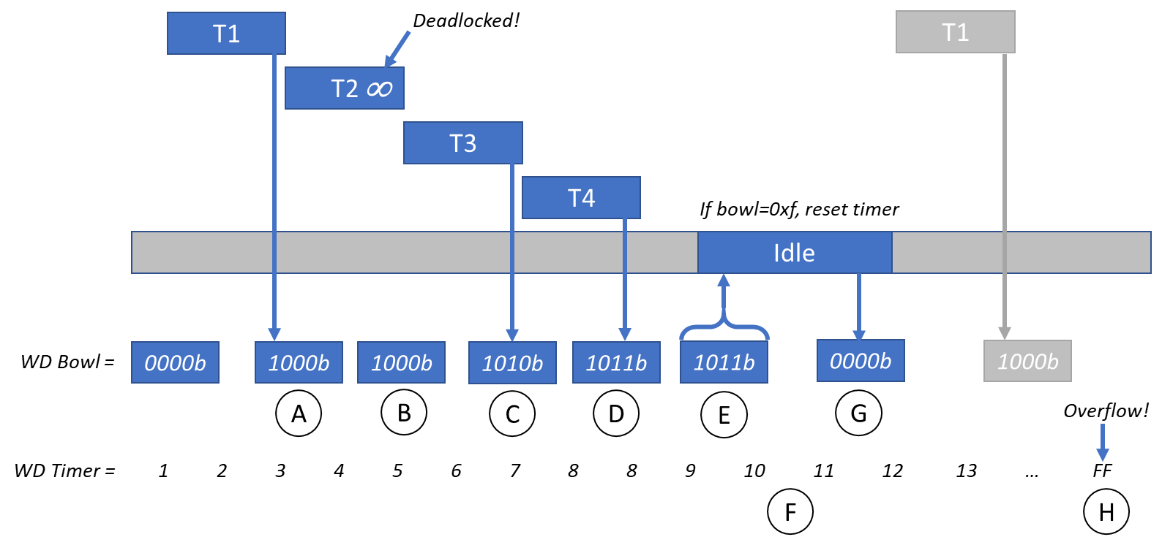

Web Service

Testing

Performance

Accomplishments

Possible Improvements

Closing Remarks

References

- https://www.networkworld.com/article/3093439/throwing-our-iot-investment-in-the-trash-thanks-to-netgear.html
- FreeRTOS Reference

References

[1] | A. Zeichick, "Throwing our IoT investment in the trash thanks to NetGear," Network World, 11 July 2016.
[2] | R. Barry, "Mastering the FreeRTOS Real Time Kernal," Real Time Engineers Ltd, 2016.

